Recent progress in natural drug development

By Prof. Marc Diederich and James Bowers PhD

1. Antique anti-coagulants may hold the key to a new lung cancer treatment

Genetic variations in patients can render lung cancer medicines ineffective. Prof. Marc Diederich and his colleagues ascertained a biscoumarin-derivative to target patients that are resistant to other treatments.

Lung cancer is the most common cancer in the world and, with such a crucial role of this organ in the human body, it’s easy to understand the importance of finding an effective cure. Current research into finding new treatments aims at seeking molecules that can attack specific cancer cells. However, not every patient or cancer are the same due to genetic variation and this means that we are unlikely to find a one-size-fits-all medicine. A simple difference in the genetic code can make cancer cells resistant to treatments.
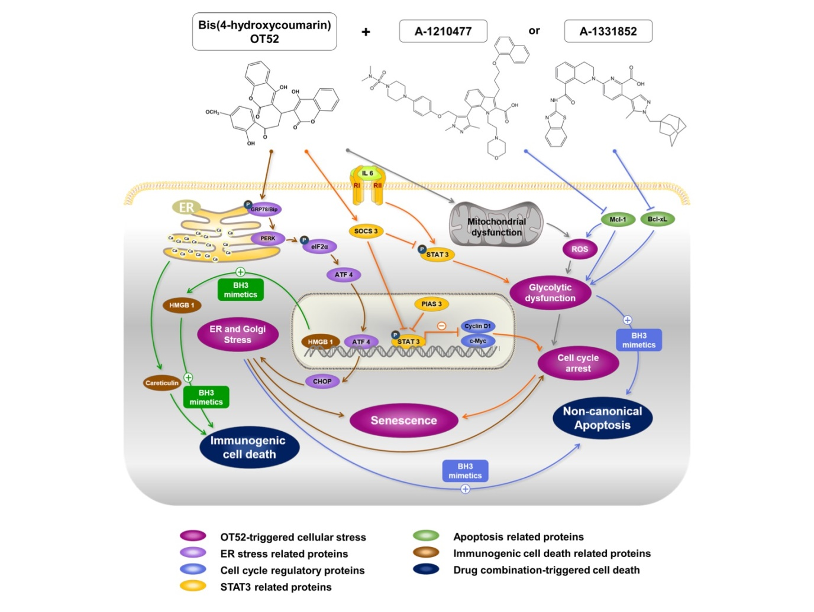

Dicoumarol: a long history
Prof. Marc Diederich’s team focus a lot of their research on finding new cures to target specific cancer cells that are normally resistant to other therapies. They focus on developing derivatives of natural molecules and their most recent trial used a re-synthesized version of the molecule biscoumarin; a derivative of dicoumarol.
Dicoumarol, an anti-coagulant like warfarin, has quite unique origins being first discovered 1939 by Dr. Karl Paul Link. A decade earlier, in the 1920s, Dr. Link laid his hands on some blood samples collected from cows during an epidemic in the US and Canada. Lots of cattle at the time were dropping dead in the masses due to blood loss through hemorrhaging. It was later discovered that the clovers and hay the cows were eating had gone rotten.
As it turns out the fungus rotting the hay was also responsible for a significant chemical change in the food supply. The fungus growing on the clover converted coumarin, which is produced naturally by the plants, into dicoumarol. After the cows ate the hay, the dicoumarol entered their bloodstream where it acted as a very powerful anti-coagulant, leading to death by uncontrollable bleeding. It sounds quite distasteful but from this discovery, anti-coagulants such as warfarin were developed and used as medicines.

Dicoumarol derivatives: anticoagulants as innovative lung cancer cures?
Now, in 2018, Prof. Marc Diederich and his team have published results using molecules derived from the same origin. Their paper in Cancer Letters, shows how a modified and re-synthesized version of biscoumarin obtained from the lab of Prof. Artur Silva (University of Aveiro, Portugal) can destroy lung cancer cells and synergize with last generation targeted anticancer drugs, the so called BH3 mimetics. It even worked in cells that are resistant to other treatments and so could provide a new drug molecule to treat lung cancer – particularly in patients where other molecules are ineffective.

2. Diallyl sulfides from garlic, can be used to prevent growth and division of colorectal cancer cells.

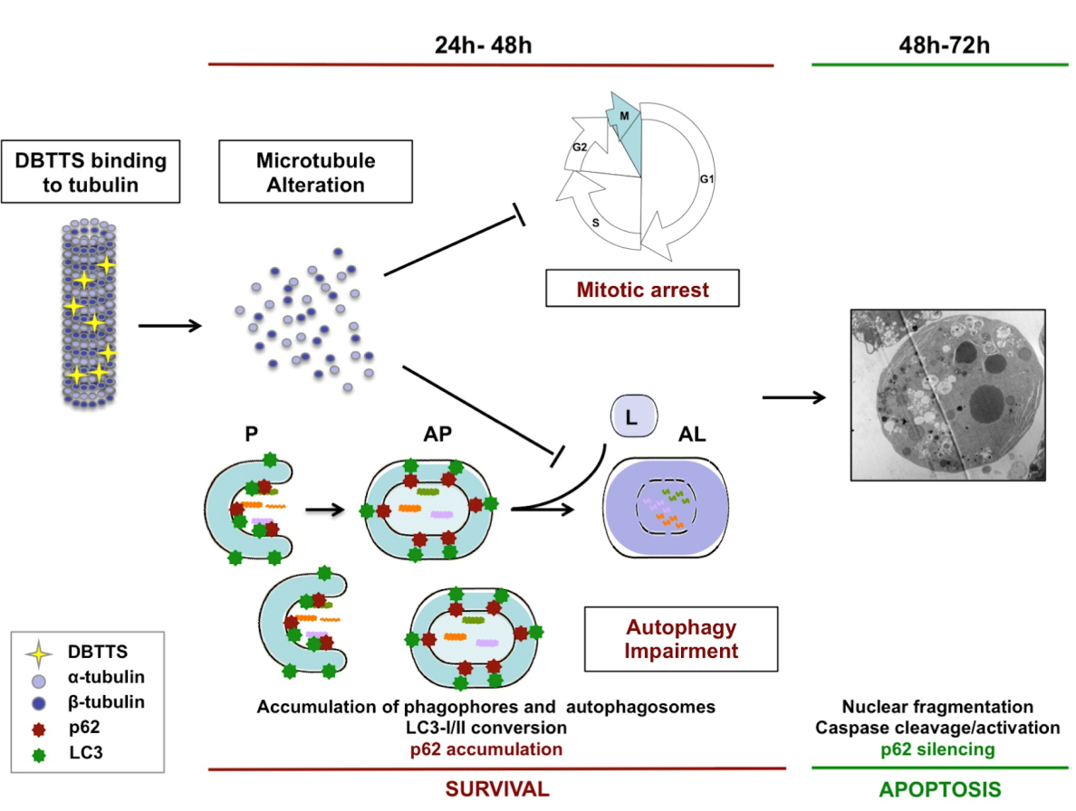

Colorectal cancer, or bowel cancer as it is more commonly known, is the second leading cause of cancer-related deaths worldwide and the third most common form of cancer overall (excluding skin cancers). Advances in testing and treatment have greatly improved in recent years, but beneficial effects of chemotherapy are still drastically reduced in later stages of the disease. Scientists had previously discovered that a diet containing plenty of onions and garlic seemed to protect against certain types of cancer, and as a result Prof. Marc Diederich decided to study different molecules from these vegetables. They identified two - diallyl tetrasulfide and dibenzyl tetrasulfide - as potentially useful.

After the Chemicals Are Extracted, How are They Used?

Former research by Prof. Marc Diederich’s team had shown that certain molecules extracted from garlic actually stop normal cell division and increase cell death, both of which are extremely valuable tools in targeting cancer cells. In their most recent paper in Cancer Letters, Prof. Marc Diederich’s team demonstrated the possibility of how these molecules could act specifically against colorectal cancer cells.

They had discovered that both diallyl tetrasulfide and dibenzyl tetrasulfide are capable of binding to another molecule which happens to be found in all cells, tubulin. This simple molecule acts like small “lego” pieces, which can be ‘snapped’ together inside cells to produce long filaments. These filaments end up as a skeleton-like structure, which continually grows and shrinks inside the cell, depending on what the cell happens to be doing at that time. For example, when the cell prepares to divide, the long filaments need to shrink. However, when one of either of the molecules found in garlic is present, it binds to the tubulin, locking the “lego” pieces in place. This prevents the cancer cell from dividing and ultimately multiplying. This is actually a mechanism already used by the common cancer treatment, Taxol. However, Taxol is not capable of effectively treating all cancers as some are resistant to its effect.

As they had done in many of their other studies, the team further tested the effects of synthesized versions of the garlic extracts in living tissue using a signature technique known as “xenografts”. This involves transplanting live colorectal tumors into zebrafish and the researchers in this study were able to stop the growth of cancer cells using the garlic extracts. Going forward, the team hopes that the treatment will work in more complex species and eventually humans, making it an all-natural solution to beating colorectal cancer.

3. A new synthetic treatment against brain tumors may be just around the corner
Another collaboration led by Prof. Marc Diederich offers promising results as the team identify a new man-made compound capable of attacking brain tumor cells.

New data suggests that as many as one in two of us will suffer from cancer at some point in our lives and whilst treatment is improving, prognosis is still very bad for many cancer types...
New data suggests that as many as one in two of us will suffer from cancer at some point in our lives and whilst treatment is improving, prognosis is still very bad for many cancer types. Cancer in the brain manifests itself as a tumor, an out-of-control mass of brain cells that even develops its own blood supply as it expands. As many as 80,000 people are expected to be diagnosed with a brain tumor this year in the USA alone.

How do scientists come up with new treatments?
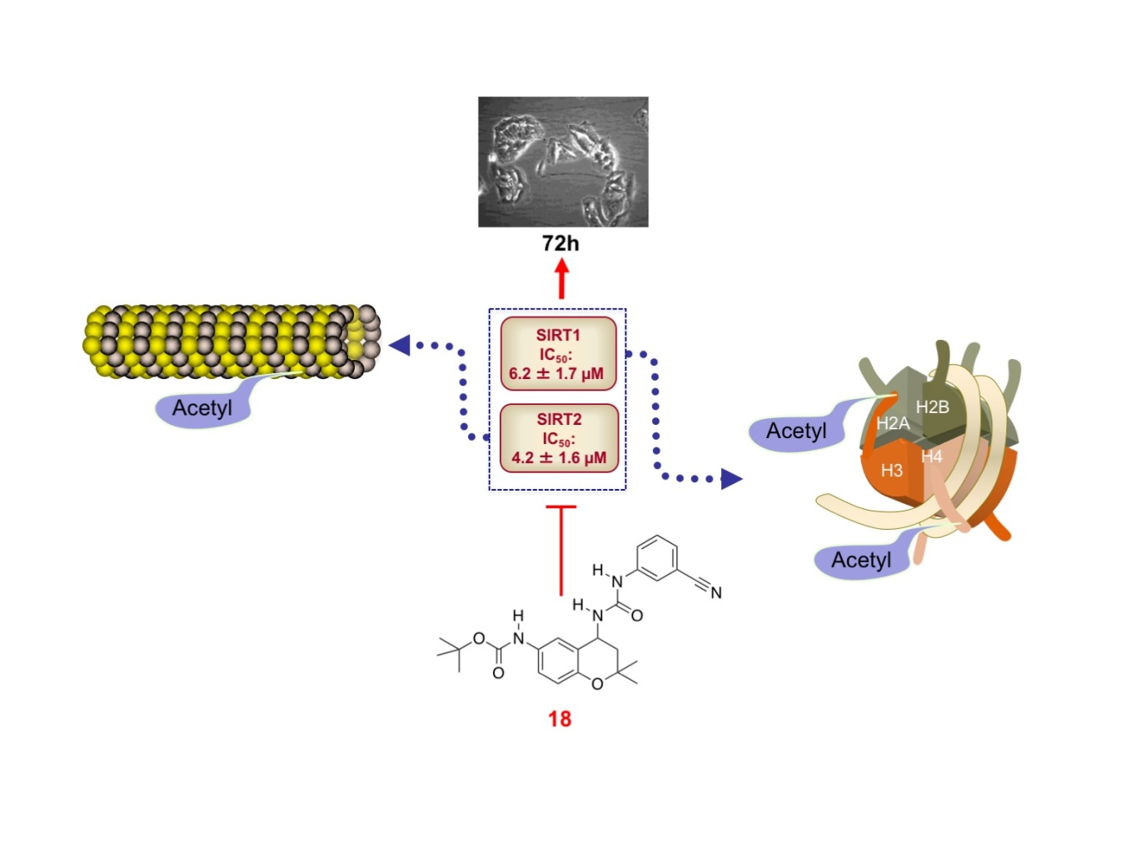
Firstly, a target must be chosen. In this case, the most common type of brain tumor is a glioma, originating from glial cells – target identified. Next, a molecule must be proposed to use as a drug. Out of the millions of options available, it must be decided whether to test chemicals that already exist or to specifically design new molecules.

Prof. Marc Diederich and his teams spend a lot of their time sifting through what already exists. They test thousands of different, naturally-occurring molecules just in case they have an effect on cancer cells. Every so often it works and one of the molecules tested will be effective.

The other option is to take molecules that we know interact with cells we want to target and tweak their structure slightly to hopefully make them more aggressive against the cancer. To create new molecules in this way, the LBMCC teamed up with researchers from Austria, Belgium and Korea for a cross-disciplinary collaboration.

The group took two types of molecules (cromakalim and ureas/thioureas) that are known to affect certain human cells that have a similar function to those we find in the brain. They looked at the physical structures of these molecules and designed a series of new ones taking different bits of each of them. Of the 18 resulting hybrid molecules, one was a winner.

Too new to name

The successful molecule, currently named compound 18, is efficient at stopping brain cancer cell growth without affecting healthy cells. Compound 18 does this by blocking the activity of certain genes such as SIRT1 and SIRT2 that are known to be necessary in tumor survival.

Prof. Marc Diederich and his teams have so far demonstrated the effects of compound 18 in glial cell models and zebrafish. The next step will be to run further in vivo tests in the hopes of moving towards future clinical trials.

